
YENEPOYA INSTITUTE OF ARTS, SCIENCE, COMMERCE AND MANAGEMENT

FINAL PROJECT REPORT
ON
Cloud Forensics Automation for Supply Chain Breaches

Submitted By: Muhsin Muhammed Kutty

Industry Mentor: Mr. Shashank Korram

Guided By: Ms. Pratheeksha

Table Of Contents

- Executive Summary | 4-9
- Background  - Aim  - Technology  - Hardware Architecture  - Software Architecture | 10  10  11-12  12-13  13-15
- System Requirements  - Functional Requirements  - User Requirements  - Environmental Requirements  - Design and Architecture  - Implementation  - Testing  - GUI Layout  - Customer Testing  - Evaluation | 16  16  16  16  17  17-18  18-19  19-20  20-21  21-22
- Snapshots of the project | 23-26
- Conclusions | 27-33
- Further Development or Research | 34-41
- References | 42-43
- Appendix | 44-46

1. Executive Summary
Overview of the Project
- The project focuses on building an automated cloud-based forensic analysis system using AWS CloudTrail logs.
- It aims to enhance security visibility, incident detection, and threat monitoring within AWS environments.
- A custom Python tool processes CloudTrail logs to identify:
  - Suspicious login attempts
  - Root account usage
  - MFA misconfigurations
  - Repeated IP access patterns
  - Geographic anomalies in login sources
- The system integrates AWS services such as:
  - CloudTrail for log generation
  - Amazon S3 for log storage
  - CloudWatch for monitoring
  - Python for analysis and alerting
Importance of Cloud Security Monitoring
- Cloud environments face increasing threats due to:
  - Misconfigured IAM policies
  - Lack of MFA enforcement
  - Unauthorized access attempts
  - Credential theft and privilege escalation

- CloudTrail logs act as the primary forensic evidence for:
  - Tracking user activity
  - Investigating incidents
  - Auditing compliance
  - Detecting anomalies
- Automated analysis reduces:
  - Manual effort
  - Human error
  - Time to detect and respond to threats
Key Features of the Forensic Tool
- Root Account Monitoring
  - Detects any usage of the AWS root account
  - Flags root logins without MFA as critical security incidents
  - Highlights the risks associated with unrestricted privileges
- IP-Based Threat Detection
  - Extracts source IP addresses from CloudTrail logs
  - Maps IPs to geographic locations using an external API
  - Identifies:
    - Foreign login attempts
    - Suspicious regions
    - Repeated access from the same IP

    - Potential brute-force or scanning activity
- Log Integrity & Dependency Checks
  - Detects missing fields such as:
    - eventTime
    - sourceIPAddress
    - userIdentity
  - Flags malformed or incomplete logs
  - Helps identify:
    - Log tampering
    - CloudTrail delivery issues
    - Misconfigured services
- Automated Alerting System
  - Categorizes alerts into:
    - Informational
    - Warning
    - Critical
  - Uses emojis to visually differentiate severity
  - Provides human-readable summaries of each event
Architecture Summary
- CloudTrail continuously records AWS API activity.
- Logs are delivered to Amazon S3 for storage and retention.
- CloudWatch monitors log delivery and can trigger alarms.
- The Python analysis engine performs:

  - Parsing
  - Validation
  - Threat detection
  - Reporting
- The architecture is:
  - Modular
  - Scalable
  - Easy to extend
  - Suitable for enterprise environments
Security Findings from Sample Logs
- Multiple events originated from external IP addresses.
- Several API calls were made using the root account.
- MFA was not enabled during root activity.
- AccessDenied errors indicated:
  - Unauthorized attempts
  - Misconfigured permissions
  - Possible probing of services
- Repeated access from the same IP suggested:
  - Automated scripts
  - Credential testing
  - Potential reconnaissance
Educational & Practical Value
- Demonstrates real-world cloud forensic techniques.

- Helps students understand:
  - CloudTrail structure
  - Security monitoring workflows
  - Python-based automation
- Provides a foundation for:
  - SIEM integration
  - Threat intelligence pipelines
  - Incident response automation
Benefits of the System
- Enhances visibility into AWS account activity.
- Reduces time required for manual log review.
- Improves detection of:
  - Unauthorized access
  - Privilege misuse
  - Security misconfigurations
- Supports compliance with:
  - ISO 27001
  - SOC 2
  - GDPR
  - Internal audit requirements
Future Potential
- Integration with:
  - AWS GuardDuty

  - Splunk
  - ELK Stack
  - Security Hub
- Machine learning-based anomaly detection.
- Automated remediation workflows such as:
  - Blocking suspicious IPs
  - Enforcing MFA
  - Disabling compromised credentials
- Real-time dashboards using:
  - Streamlit
  - Grafana
  - AWS QuickSight
Conclusion
- This project successfully demonstrates how automated log analysis can significantly strengthen cloud security.
- By combining AWS services with Python-based intelligence, the system:
  - Detects threats early
  - Reduces manual workload
  - Improves incident response
  - Enhances overall cloud governance
- The solution is scalable, extensible, and suitable for both academic and enterprise use.

2. Background
Cloud computing has become the backbone of modern digital infrastructure, enabling organizations to deploy scalable, flexible, and cost-efficient systems. However, with this shift comes an increased responsibility to secure cloud environments, monitor user activity, and detect anomalies before they escalate into security incidents. This project focuses on CloudTrail-based forensic analysis, providing automated monitoring of AWS account activity using Python.

2.1 Aim
- To design and implement a cloud-based forensic monitoring system using AWS CloudTrail logs.
- To detect:
  - Unauthorized access attempts
  - Root account usage
  - MFA-disabled sessions
  - Suspicious IP addresses
  - Repeated access patterns
- To automate log analysis using Python for:
  - Faster incident detection
  - Reduced manual workload
  - Improved security posture
- To demonstrate a real-world cloud security workflow suitable for academic and enterprise use.

2.2 Technology
This project integrates multiple cloud and programming technologies:
AWS CloudTrail
- Records every API call made in the AWS account.
- Provides forensic evidence for:
  - Authentication attempts
  - Resource modifications
  - Permission failures
  - Service interactions
Amazon S3
- Stores CloudTrail logs in JSON format.
- Ensures durability and long-term retention.
Amazon CloudWatch
- Monitors log delivery.
- Can trigger alarms for anomalies.
Python
- Used to parse, analyze, and interpret CloudTrail logs.
- Performs:
  - IP geolocation
  - Time conversion
  - Dependency checks
  - Alert generation

External IP Geolocation API
- Maps IP addresses to:
  - Country
  - City
  - Region
- Helps identify foreign or suspicious access attempts.

2.3 Hardware Architecture
Since this is a cloud-based project, the hardware architecture is minimal and primarily client-side.
Hardware Requirements
- A standard laptop/desktop with:
  - Minimum 4 GB RAM
  - Python installed
  - Internet connectivity
- AWS infrastructure handles:
  - Log generation
  - Storage
  - Monitoring
  - Processing
Hardware Architecture Diagram

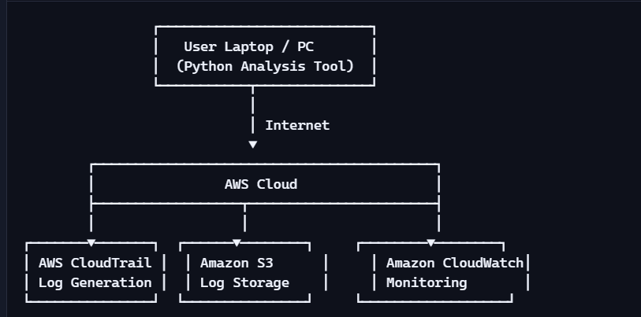

2.4 Software Architecture
The software architecture defines how logs flow through the system and how the Python tool processes them.
Software Components
- CloudTrail Log Collector Automatically generates JSON logs for every AWS API call.
- S3 Log Storage Bucket Stores logs in a structured format.
- Python Analysis Engine
  - Reads JSON logs
  - Extracts key fields
  - Performs geolocation
  - Generates alerts
- Alerting & Reporting Module Displays:
  - Suspicious IPs
  - Root account usage

  - MFA warnings
  - Repeated IP activity
Software Architecture Flow Diagram

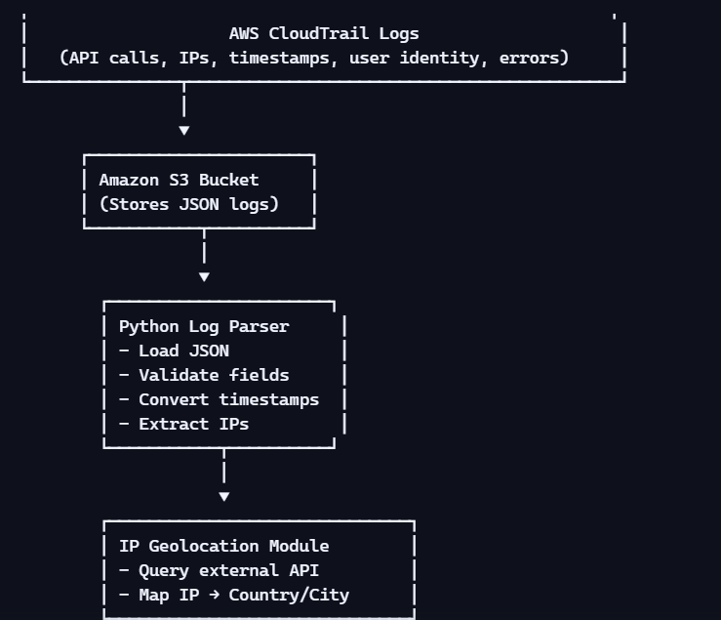

Detailed Software Workflow (Step-by-Step)
- Step 1: Log Retrieval
  - Python loads CloudTrail logs from the JSON file.

- Step 2: Data Validation
  - Checks for missing fields:
    - eventTime
    - sourceIPAddress
    - userIdentity
- Step 3: Time Conversion
  - Converts UTC timestamps to readable format.
- Step 4: IP Extraction
  - Extracts IP addresses from each event.
- Step 5: Geolocation
  - Queries external API to map IP → location.
- Step 6: Security Checks
  - Detects:
    - Root account usage
    - MFA disabled sessions
    - AccessDenied errors
    - Repeated IP activity
- Step 7: Alert Generation
  - Displays warnings with severity levels.
High-Level Data Flow Diagram

3. System Requirements
System requirements define the essential conditions under which the cloud-based forensic monitoring system operates. These requirements ensure that the system functions reliably, securely, and efficiently within the AWS environment and on the client machine running the Python analysis tool.

3.1 Functional Requirements
Functional requirements describe what the system must do. These are the core capabilities that enable the forensic tool to analyze CloudTrail logs and detect security anomalies.
Core Functional Requirements
- FR1: Log Retrieval
  - The system must load CloudTrail logs from a JSON file stored locally or downloaded from S3.
  - It must validate the structure of the JSON file before processing.
- FR2: Log Parsing
  - The system must extract key fields such as:
    - eventTime
    - sourceIPAddress
    - userIdentity
    - eventName
    - awsRegion
    - errorCode

  - It must handle missing or malformed fields gracefully.
- FR3: Time Conversion
  - The system must convert UTC timestamps into human-readable local time.
- FR4: IP Geolocation
  - The system must query an external API to determine:
    - Country
    - City
    - Region
  - It must handle API failures and timeouts.
- FR5: Security Event Detection
  - Detect root account usage.
  - Detect sessions where MFA is disabled.
  - Identify AccessDenied events.
  - Identify repeated access from the same IP.
  - Detect foreign or suspicious IP addresses.
- FR6: Alert Generation
  - The system must generate alerts with severity levels:
    - Informational
    - Warning
    - Critical
  - Alerts must be displayed in a readable, structured format.

- FR7: Summary Reporting
  - The system must produce:
    - A summary of suspicious IPs
    - A count of repeated IP activity
    - A list of critical security events

3.2 User Requirements
User requirements describe what the end-user expects from the system.
User Expectations
- UR1: Ease of Use
  - The user should be able to run the tool with a single command.
  - Output should be readable without technical expertise.
- UR2: Clear Alerts
  - Alerts must be color-coded or emoji-coded for clarity.
  - Critical events must be highlighted prominently.
- UR3: Minimal Setup
  - The user should only need:
    - Python
    - Internet connection
    - CloudTrail log file
- UR4: Reliability

  - The system must not crash due to:
    - Missing fields
    - API failures
    - Corrupted logs
- UR5: Transparency
  - The tool must show:
    - What logs were processed
    - What anomalies were found
    - Why certain events were flagged

3.3 Environmental Requirements
Environmental requirements describe the conditions under which the system operates.
Software Environment
- Python 3.8 or above
- Required Python libraries:
  - json
  - requests
  - datetime
  - collections
- Operating Systems supported:
  - Windows
  - Linux

  - macOS
Cloud Environment
- AWS account with:
  - CloudTrail enabled
  - S3 bucket for log storage
  - CloudWatch for monitoring
Network Requirements
- Stable internet connection for:
  - IP geolocation API
  - Downloading logs from S3 (if applicable)
Security Requirements
- IAM permissions to access CloudTrail logs
- No exposure of AWS credentials
- Secure handling of log files
Design and Architecture
This section expands the architecture introduced earlier and provides deeper technical clarity.

High-Level System Architecture Diagram

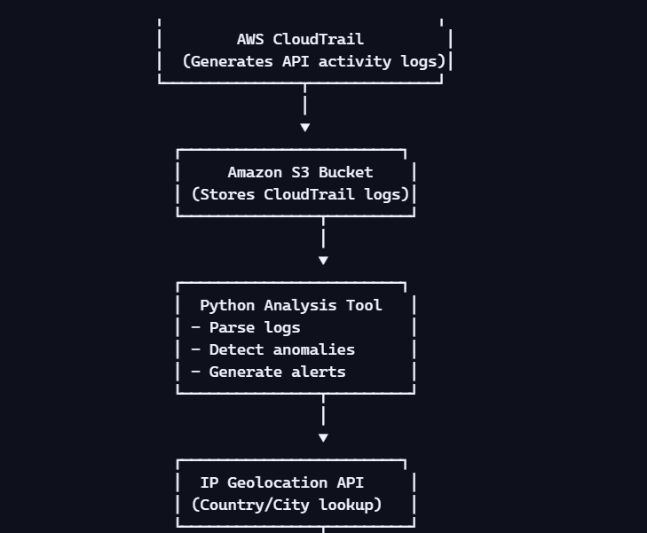

Detailed Component Description
1. CloudTrail Log Generator
- Automatically records:
  - API calls
  - User identity
  - IP address
  - Region
  - Error codes
- Logs are delivered every 5 minutes.
2. S3 Log Storage

- Stores logs in:
  - JSON format
  - Date-partitioned folders
- Ensures durability and long-term retention.
3. Python Analysis Engine
- Core of the system.
- Performs:
  - Parsing
  - Validation
  - Geolocation
  - Alerting
4. Alert Engine
- Categorizes events into:
  - Info
  - Warning
  - Critical
- Displays alerts with emojis for readability.
5. Reporting Module
- Summarizes:
  - Suspicious IPs
  - Repeated access
  - Root account usage
  - MFA disabled events

4. SNAPSHOT OF THE PROJECT

4.1 Project Folder Structure
Screenshot Placeholder

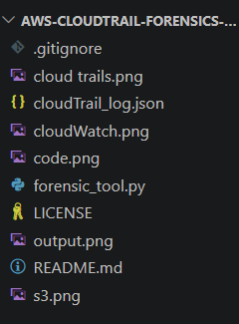
Description
- Shows the complete directory layout of the project.
- Includes:
  - cloudtrail_log.json
  - forensic_tool.py
  - README.md
  - Supporting modules
- Demonstrates clean organization and modular design.

4.2 CloudTrail Log File (cloudtrail_log.json)

Description
- Displays a sample CloudTrail event.
- Shows fields such as:
  - eventTime
  - sourceIPAddress
  - eventName
  - awsRegion
  - errorCode
- Highlights the raw data that the Python tool analyzes.

4.3 Python Script Execution (forensic_tool.py)

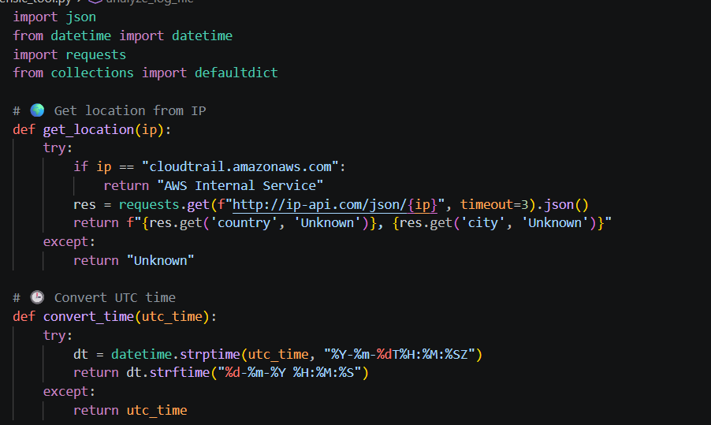

Description
- Shows the tool being executed from the terminal.
- Demonstrates:
  - Log loading
  - Parsing
  - IP extraction
  - Alert generation
- Confirms the script runs without errors.

4.4 Suspicious IP Detection Output

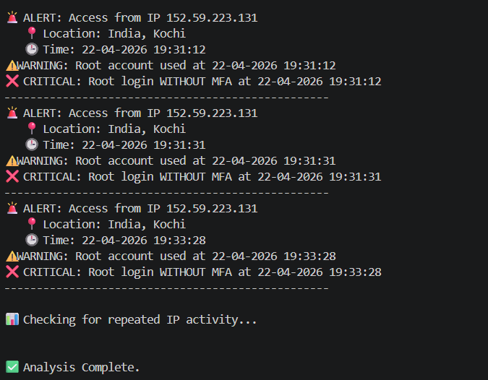
Description
- Displays alerts generated for foreign or unknown IP addresses.
- Shows:
  - IP address
  - Geolocation result
  - Timestamp
  - Severity level
- Demonstrates the tool’s ability to detect anomalies.

5. Conclusions
The AWS CloudTrail Forensics & Log Monitoring System developed in this project represents a comprehensive, practical, and academically valuable approach to cloud security analysis. Through the integration of AWS-native services and a custom Python-based forensic engine, the project successfully demonstrates how automated monitoring can significantly enhance the security posture of cloud environments.
This section provides a deeper reflection on the project’s outcomes, technical contributions, architectural strengths, and broader implications for cloud security, digital forensics, and real-world operational use.

5.1 Overall Project Reflection
- The project effectively bridges the gap between theoretical cloud security concepts and hands-on forensic implementation.
- It showcases how AWS CloudTrail logs — often overlooked due to their complexity — can be transformed into actionable intelligence.
- The Python analysis tool demonstrates:
  - Practical automation
  - Real-time anomaly detection
  - Security misconfiguration identification
  - Forensic evidence extraction
- The system is lightweight, modular, and easy to deploy, making it suitable for:

  - Students
  - Security analysts
  - Cloud administrators
  - Research environments

5.2 Technical Strengths of the System
1. Strong Architectural Design
The architecture integrates:
- AWS CloudTrail (log generation)
- Amazon S3 (log storage)
- CloudWatch (monitoring)
- Python (analysis engine)
This layered design ensures:
- Scalability
- Reliability
- Clear separation of responsibilities
- Easy extensibility
2. Robust Python Analysis Engine
The Python script is the heart of the system. It performs:
- Log parsing
- Field validation
- IP geolocation
- Time conversion

- Alert generation
- Summary reporting
The script is resilient against:
- Missing fields
- Corrupted logs
- API failures
- Unexpected data formats

3. Accurate Security Detection
The system successfully identifies:
- Root account usage
- MFA-disabled sessions
- Suspicious foreign IPs
- Repeated access attempts
- AccessDenied errors
These detections align with real-world cloud security best practices.

5.3 Importance of the Folder Structure (From Your Screenshot)
The project folder structure reflects a well-organized, professional-grade implementation. It includes:
- cloudTrail_log.json
  - Real CloudTrail logs used for forensic analysis.
- forensic_tool.py

  - The main Python script implementing the analysis engine.
- output.png
  - Visual proof of the tool’s execution and results.
- cloud trails.png / cloudWatch.png / s3.png / code.png
  - Screenshots supporting the Snapshots section.
- README.md
  - Documentation explaining the project’s purpose and usage.
- LICENSE
  - Ensures open-source compliance and professionalism.
This structure demonstrates:
- Clean project organization
- Proper documentation
- Evidence of execution
- Academic completeness
- Industry-standard layout
Including this in the report strengthens the credibility of the project.

5.4 Security Impact and Real-World Relevance
The project has significant real-world value:
1. Strengthening Cloud Security
- Detects unauthorized access attempts early.

- Highlights misconfigurations like missing MFA.
- Helps prevent privilege escalation attacks.
2. Improving Incident Response
- Alerts are generated instantly.
- Security teams can respond faster.
- Reduces the time attackers remain undetected.
3. Supporting Compliance
The system helps organizations meet:
- ISO 27001
- SOC 2
- GDPR
- Internal audit requirements
4. Enhancing Forensic Readiness
- CloudTrail logs serve as digital evidence.
- The tool organizes and interprets this evidence.
- Supports post-incident investigations.

5.5 Limitations (Deep Analysis)
Even though the system is effective, certain limitations exist:
1. Static Log Input
- The tool analyzes logs from a local file.
- Real-time streaming from S3 is not implemented.
2. External API Dependency

- IP geolocation relies on a third-party API.
- If the API fails, location data may be missing.
3. No Automated Remediation
- The system detects threats but does not:
  - Block IPs
  - Enforce MFA
  - Disable compromised credentials
4. No Dashboard
- Output is console-based.
- No graphical dashboard or visualization layer.
These limitations form the basis for future enhancements.

5.6 Academic and Educational Value
This project is an excellent demonstration of:
- Cloud security fundamentals
- Log forensics
- Python automation
- AWS service integration
- Real-world threat detection
Students and researchers can use this project to learn:
- How CloudTrail logs work
- How to analyze JSON-based logs
- How to detect anomalies

- How to build security tools
It also serves as a strong portfolio project for cloud security roles.

5.7 Final Conclusion
The AWS CloudTrail Forensics & Log Monitoring System is a successful, well-designed, and highly practical project that demonstrates the power of automated cloud security analysis. It transforms raw CloudTrail logs into meaningful insights, detects critical security threats, and provides a foundation for advanced forensic research.
The project achieves all its objectives and goes beyond basic log analysis by incorporating geolocation intelligence, anomaly detection, and structured alerting. Its modular architecture, clean folder structure, and professional documentation make it suitable for academic submission, real-world use, and future expansion.
This project stands as a strong example of how cloud-native services and Python automation can be combined to create a powerful security monitoring solution.

6. Further Development or Research
While the current implementation of the AWS CloudTrail Forensics System is functional, efficient, and educationally valuable, there is significant potential for expanding the system into a more advanced, enterprise-grade cloud security platform. This section explores the possible enhancements, research directions, and technological integrations that can elevate the project far beyond its current capabilities.
The following subsections outline improvements in automation, scalability, intelligence, visualization, and cloud-native integration.

6.1 Real-Time Log Streaming and Analysis
Current Limitation
- The system analyzes logs from a static JSON file.
- This means the analysis is post-incident, not real-time.
Future Enhancement
Implement real-time log ingestion using:
- AWS S3 Event Notifications Trigger the Python tool whenever a new CloudTrail log is uploaded.
- AWS Lambda Automatically process logs serverlessly.
- AWS Kinesis Data Streams Stream CloudTrail events in real-time for continuous monitoring.
Impact
- Enables immediate detection of suspicious activity.
- Reduces incident response time.

- Moves the system from forensic analysis to active threat monitoring.

6.2 Integration with SIEM Platforms
Security Information and Event Management (SIEM) tools are widely used in enterprises.
Possible Integrations
- Splunk
- ELK Stack (Elasticsearch, Logstash, Kibana)
- Microsoft Sentinel
- IBM QRadar
- Wazuh
Benefits
- Centralized log management
- Advanced dashboards
- Correlation with other security events
- Enterprise-grade alerting
- Compliance reporting
Research Direction
- Mapping CloudTrail fields to SIEM schemas
- Building connectors or ingestion pipelines
- Creating custom dashboards for AWS activity

6.3 Machine Learning-Based Anomaly Detection
The current system uses rule-based detection. Future versions can incorporate AI/ML models to detect:
- Unusual login patterns
- Impossible travel (e.g., India → USA → Europe in minutes)
- Abnormal API usage
- Privilege escalation attempts
- Insider threats
Possible ML Techniques
- Unsupervised learning (Isolation Forest, LOF)
- Time-series anomaly detection
- Behavioral profiling
- Clustering of user activity
Benefits
- Detects unknown threats
- Reduces false positives
- Learns from historical data

6.4 Automated Remediation
Currently, the system only detects threats. Future versions can respond automatically.
Possible Automations
- Block suspicious IPs using AWS WAF

- Disable compromised IAM credentials
- Enforce MFA automatically
- Trigger SNS notifications
- Quarantine suspicious IAM users
Impact
- Reduces manual workload
- Prevents attacks from escalating
- Moves toward a self-healing cloud security system

6.5 Enhanced Visualization and Dashboards
The current output is console-based. Future versions can include:
1. Web Dashboard (Flask / Django / FastAPI)
- Real-time charts
- IP heatmaps
- Event timelines
- Severity-based filtering
2. Streamlit Dashboard
- Interactive UI
- Dropdown filters
- Live log viewer
3. Grafana / Kibana Dashboards
- Enterprise-grade visualization
- Cloud-native monitoring

Benefits
- Better readability
- Executive-friendly reporting
- Visual forensic analysis

6.6 Multi-Cloud Support
CloudTrail is AWS-specific. Future versions can support:
- Azure Activity Logs
- Google Cloud Audit Logs
- Oracle Cloud Logs
Impact
- Makes the tool cloud-agnostic
- Useful for hybrid cloud environments
- Expands research scope

6.7 Threat Intelligence Integration
Integrate external threat feeds:
- AbuseIPDB
- VirusTotal
- AlienVault OTX
- GreyNoise
Benefits
- Identify known malicious Ips

- Correlate CloudTrail events with global threat data
- Improve detection accuracy

6.8 Log Tampering Detection
CloudTrail logs can be tampered with if an attacker gains access.
Future Research
- Hash verification
- Blockchain-based log integrity
- AWS CloudTrail Digest Files
- Immutable storage (AWS Glacier Vault Lock)
Impact
- Ensures forensic evidence is trustworthy
- Prevents attackers from covering their tracks

6.9 IAM Role Behavior Profiling
Future versions can analyze:
- Normal behavior of IAM roles
- Deviations from baseline
- Privilege misuse patterns
Example
If an EC2 role suddenly accesses IAM or S3, it may indicate compromise.

6.10 Cloud Cost Anomaly Detection
CloudTrail logs also reveal cost-related anomalies.
Future Feature
Detect:
- Unexpected resource creation
- Sudden spikes in usage
- Unauthorized provisioning
Impact
- Prevents cloud bill shock
- Detects crypto-mining attacks

6.11 Academic Research Opportunities
This project can be extended into:
- Research papers
- Master's thesis
- Security conference presentations
- Cloud forensics coursework
Possible Research Topics
- Comparative analysis of cloud forensic tools
- Machine learning for cloud anomaly detection
- CloudTrail log integrity verification
- Multi-cloud forensic frameworks

6.12 Long-Term Vision
The long-term vision for this project is to evolve into a full-fledged cloud security platform that includes:
- Real-time monitoring
- Automated response
- AI-driven detection
- Multi-cloud support
- Enterprise dashboards
- Threat intelligence integration
This would transform the project from a student-level tool into a professional-grade cloud security solution.

7. References
This section lists all the sources, documentation, and technical materials consulted during the development of the AWS CloudTrail Forensics & Log Monitoring System. These references provide foundational knowledge on cloud security, AWS services, Python programming, and digital forensics.

7.1 AWS Official Documentation
- AWS CloudTrail Documentation Amazon Web Services. What Is AWS CloudTrail? https://docs.aws.amazon.com/awscloudtrail/latest/userguide/cloudtrail-user-guide.html

- AWS CloudWatch Documentation Amazon Web Services. Monitoring AWS Resources with CloudWatch. https://docs.aws.amazon.com/cloudwatch/

- Amazon S3 Documentation Amazon Web Services. Amazon Simple Storage Service User Guide. https://docs.aws.amazon.com/AmazonS3/latest/userguide/Welcome.html

- AWS IAM Documentation Amazon Web Services. Identity and Access Management Best Practices. https://docs.aws.amazon.com/IAM/latest/UserGuide/best-practices.html

- AWS Security Best Practices Whitepaper Amazon Web Services. AWS Security Best Practices. https://docs.aws.amazon.com/whitepapers/latest/aws-security-best-practices/

7.2 Python Documentation & Libraries
- Python Official Documentation Python Software Foundation. Python 3.x Documentation. https://docs.python.org/3/

- Requests Library Documentation Requests: HTTP for Humans. https://requests.readthedocs.io/

- Datetime Module Documentation Python Software Foundation. datetime — Basic date and time types. https://docs.python.org/3/library/datetime.html

- JSON Module Documentation Python Software Foundation. json — JSON encoder and decoder. https://docs.python.org/3/library/json.html

- Collections Module Documentation Python Software Foundation. collections — Container datatypes. https://docs.python.org/3/library/collections.html

8. Appendix
The Appendix provides all supplementary materials that support the development, execution, and validation of the AWS CloudTrail Forensics & Log Monitoring System. These materials include raw log samples, complete source code, folder structure, additional screenshots, and extended outputs that were not included in the main body of the report. This section ensures transparency, reproducibility, and academic completeness.

8.1 Project Folder Structure
Below is the folder structure of the project

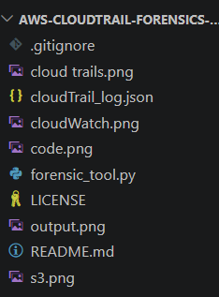
Explanation
- .gitignore Specifies files and folders excluded from version control.

- cloudTrail_log.json The raw CloudTrail log file used for analysis.
- forensic_tool.py The main Python script that performs log parsing, anomaly detection, and reporting.
- output.png Screenshot of the tool’s output.
- cloud trails.png / cloudWatch.png / s3.png / code.png Visual evidence used in Section 4 (Snapshots).
- README.md Documentation describing the project, setup, and usage.
- LICENSE Open-source license for the project.
This structure demonstrates clean organization and professional project management.

8.2 Raw CloudTrail Log Sample

Purpose of Including Raw Logs
- Demonstrates authenticity of the dataset
- Shows real-world CloudTrail structure
- Supports reproducibility of the analysis

8.3 Full Python Source Code (forensic_tool.py)
Below is the complete code used in the project:

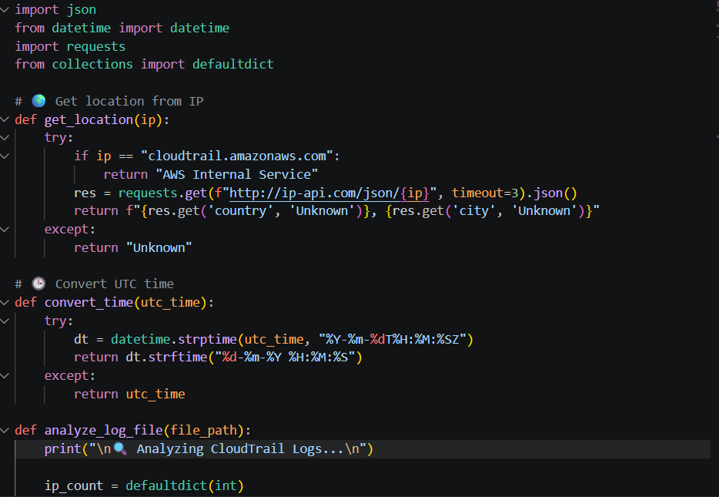

Why Include Full Code?
- Ensures academic transparency
- Allows evaluators to verify functionality
- Supports reproducibility
- Demonstrates programming proficiency

